Artemis Acceptance Test Procedure

Date: _____ / ______ / 20___ S/N: ___________________ SW Version: _______

Test Operator: ______________ Power +5Vin: _______________ Vdc (measure at PCB TP)

1) UART TX serial test: Observe Power-on banner message. Passes if message is displayed with no garbled characters. P/F: _________

2) UART RX serial test: Issue “?” help command from PC terminal. Passes if help message is displayed with no garbled characters. P/F: _________

3) FSEL Test: Cycle through binary inputs and observe channel display on serial terminal. Passes if all digits are recognized and displayed (after settling). P/F: _________

4) /MUTE Test: cycle /MUTE, and observe channel display on serial terminal. Passes if channel output toggles (muted output less or equal to -40 dBc when unmuted) P/F: _________

5) +3.3V out Test: Measure P2-15 with a DMM. Passes if voltage = 3.3V ±10%.

V(3.3V): ____________ P/F: _________

6) Sideband Test: Set CH2 and observe the output at 11 GHz on a spectrum analyzer (1 MHz span). Verify that any sidebands are ≤-40 dBc. Record strongest sideband. *Note: sidebands are considered measurable if they are greater than 3 dB above the noise floor*.

(Fc level: ________ dBm) – (SB level: _______ dBm) = _________ dBc

Span: ___________ MHz SB Frequency: Fc± ___________ (MHz) P/F: _________

7) Output level test #1: Set CH1 and observe the output at 8 GHz on a spectrum analyzer. Record the signal level. Passes if output is ≥ +10 dBm & frequency is 8 GHz +/-10KHz.

Level: __________ dBm P/F: _________

8) Output level test #2: Set CH3 and observe the output at 15 GHz on a spectrum analyzer. Record the signal level. Passes if output is ≥ 0 dBm. Level: __________ dBm P/F: _________

Set CH0, passes if 3 GHz level is ≥ +10 dBm Level: __________ dBm P/F: _________

9) Noise Test: Set CH2 and observe the output at 11 GHz on a spectrum analyzer. Center on the peak, set a 100 Khz span and measure the abs. noise level. Passes if NL is better than -78 dBc/Hz at 10KHz offset. Fc level: __________ dBm Noise level: ______________ dBm/Hz

NL (dBc) = {Noise Level} - {Fc level} = ______________ dBc/Hz P/F: _________

10) Load custom channel config and test with custom reference settings. Done: ________

REFERENCE Freq: __________________ Level: ___________________

FSEL 0: ___________________________ FSEL 1: ___________________________

FSEL 2: ___________________________ FSEL 3: ___________________________

Test Operator Signature: ___________________________________________

REV - 10/21/2024

Artemis ATP: Test Setup

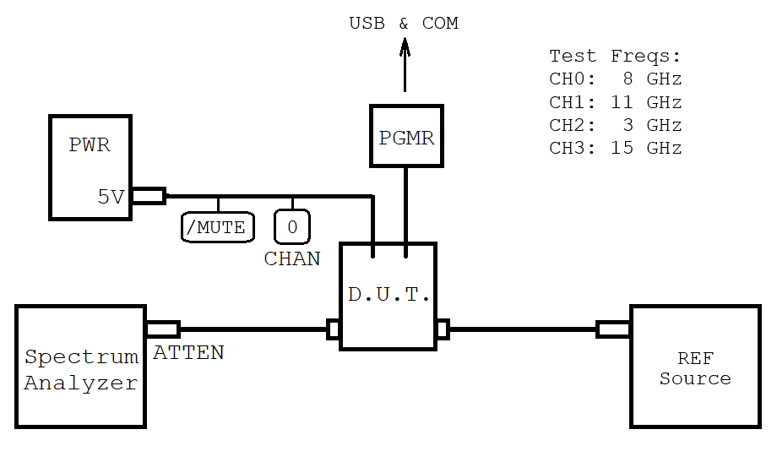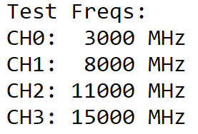

POWER SUPPLY: ______________________________________________

DMM Model/SN: _______________________________________________

S/A: __________________________________________________________

EXT. ATTEN: ______ dB ATTEN MODEL/SN: ______________________________

D.U.T. RF OUT CABLE: _________________________________________

LOSS AT 2 GHz: ________________ dB LOSS AT 12 GHz: _______________ dB

LOSS AT 8 GHz: _______________ dB LOSS AT 15 GHz: _______________ dB

ATP REF SOURCE: ______________________________________________

LEVEL AT D.U.T. CONNECTOR: ________________ dBm

Date: _____ / ______ / 20___ TEST OPERATOR: ________________________________

REV - 10/21/2024